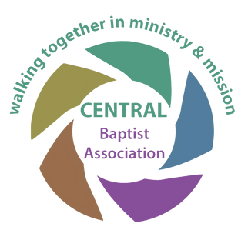
CBA – “Could Be Anything”

Grant Application Form
walking together in Ministry and Mission

WHAT DO YOU WANT TO DO?
(Provide appropriate details of how the grant will be used)

WHAT FINANCIAL HELP DO YOU NEED FROM THE ASSOCIATION?
(Provide details of the total expenditure and, if appropriate, quotes for key items required and indicate the amount of the grant being requested)

HOW WILL THE USE OF THE GRANT BLESS & IMPACT THE WIDER COMMUNITY?

WHAT ARE YOU GOING TO CONTRIBUTE?

(please read the “requirements” and “notes to guide applications” before completing this form)

ADMINISTRATIVE INFORMATION AND QUESTIONS
(the small print)

Grants applications can be made by a church, or group of churches or an individual with the support of their church. Grants will typically be given for a maximum of £5,000.

CONTACT INFORMATION
Name of applicant: .........................................................................................
Address of applicant: .........................................................................................
…………………………………………………………………
….......................................................................................... Post code:..................
Email address: ..................................................... Telephone: ..........................................

Name of church: …………………………………………………………….

Please attach a copy of the latest set of accounts of the church, the church safeguarding policy and any additional / supporting information you may wish to add.

I / We make this application and I / we certify that all the information provided is correct to the best of our knowledge and belief. We confirm that all the required documentation has been provided.

Applicant ............................................................................
Minister / Trustee ...........................................................................

Date......................................................

(A trustee for this purpose is an elder or deacon as laid down in the governing document of the church if a church application)

Please return the completed form and any accompanying documentation to: Andrew Openshaw – secretary@centralba.org.uk
Office Use:-
Date Received Date approved Payment Reference

