
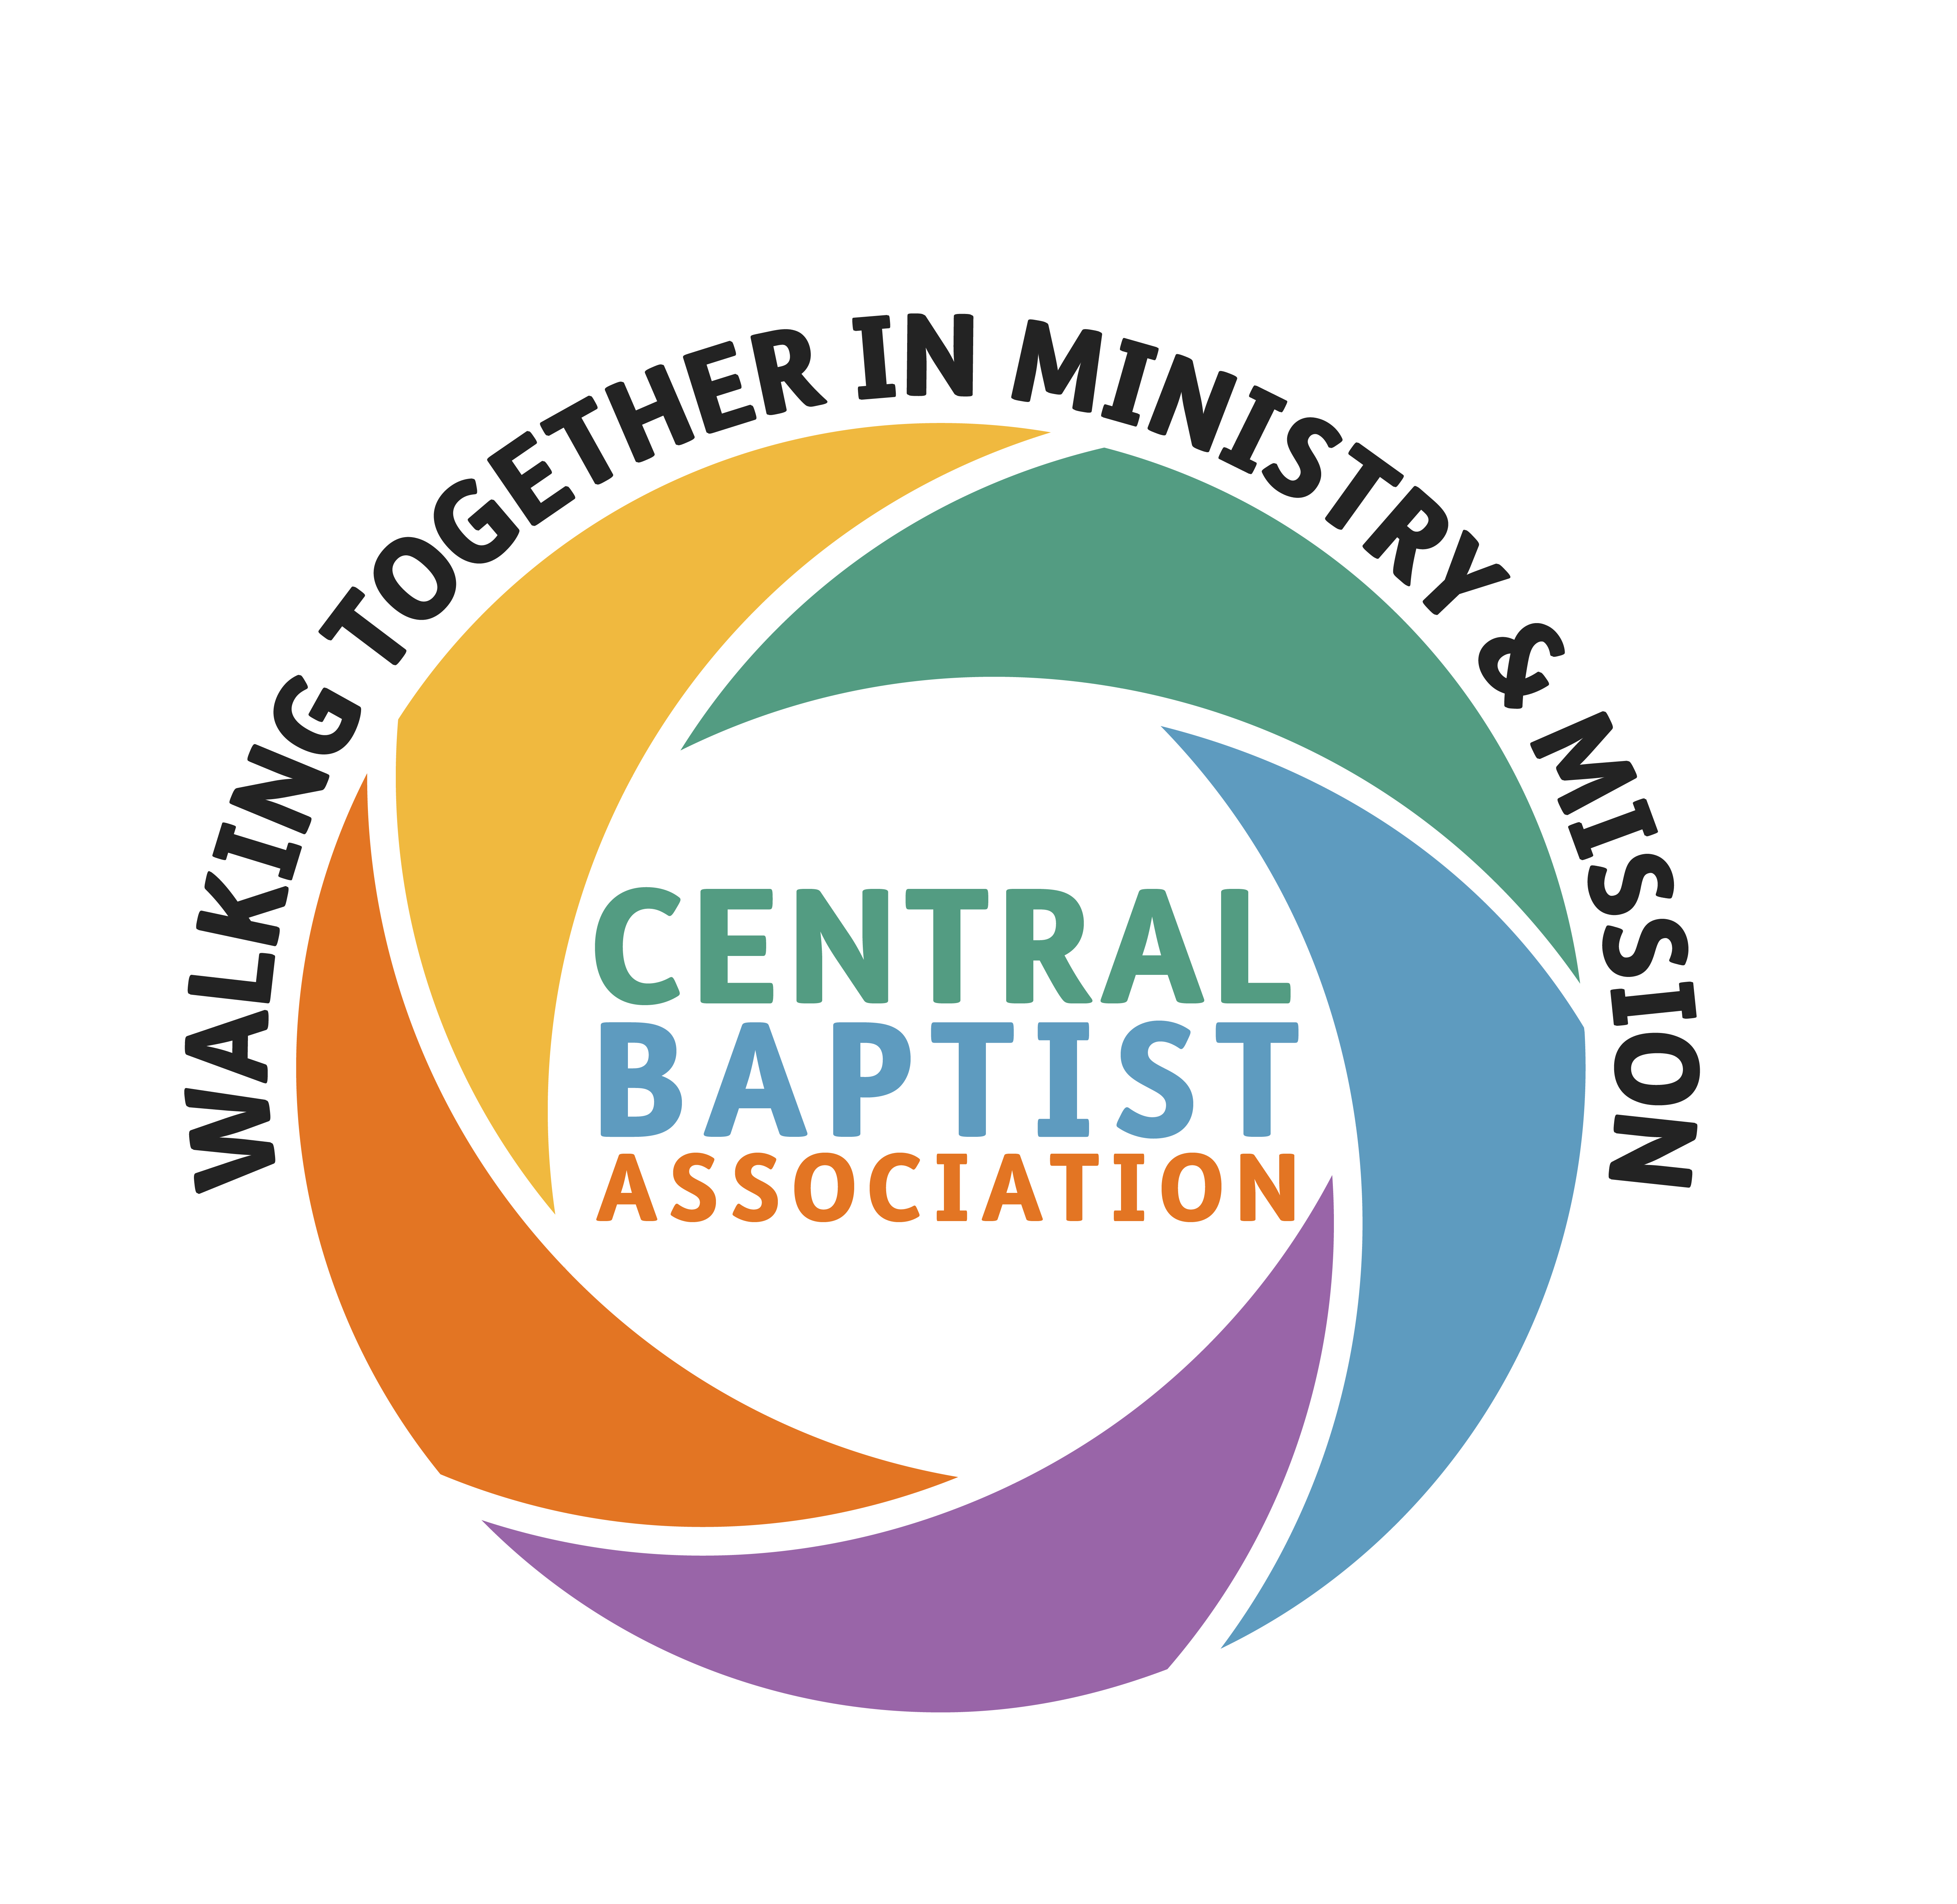
Home Mission Growth Grants for funding from Jan 2026 – Dec 2028

Guidance notes for churches (G2)
Please read the introduction through before you start to complete the G1 form – and then use the remaining notes to help you as you complete the various sections.

INTRODUCTION
General Information
- Your Home Mission Growth Grants Application Pack contains one form (G1) and these guidance notes (G2), both in Microsoft Word format. In time, we hope to create an application form that can be accessed and completed online at www.centralba.org.uk
- Please complete G1, including the declaration by Church Officers on page 1, and email to the Association: andrew.openshaw@centralba.org.uk
- You only need to send one copy of the G1 form and associated documents to the Association, but please keep a copy for your own records
- Please make sure that all supporting documents are sent within the given deadline. If you are unable to meet the deadline, please contact Andrew Openshaw.
- If you have any queries as you complete the forms, please do not hesitate to contact your Mission Enabler or your Regional Minister.

COMPLETING SECTION 1 – CONTACT DETAILS/DECLARATION/SAFEGUARDING
Page 1 must be completed fully, signed and sent to your Association as a scanned attachment.
1a. ABOUT YOU: Please provide name of church and key contact details for the most appropriate people should there be any queries about the application. Please give church website address if you have one.
1b. RESOLUTION: Before you bring the resolution to church members you will need to have decided what amount you are requesting for each of the three years from 2026-2028 – please give a figure and also express it as a percentage of standard stipend. Churches are asked to consider reducing their request each year, if possible.
Resolution A is for a Growth Grant towards an individual’s stipend. Resolution B is for a Growth Grant towards missional project costs, which may include employment costs for a key worker who will not receive a stipend. Please delete either A or B as appropriate.
- Please agree one of the two resolutions at a Church Members’ Meeting.

1c. DECLARATION: Complete the details regarding the date of the church meeting and number of members present.

The declaration should be signed and dated by two Trustees, ideally the Church Secretary/Administrator and the Church Treasurer. If they are the same person, please ask a second Trustee to sign.
- Please confirm that your safeguarding policy is up to date (page 2).
- Email your signed declaration to your Association with the G1 by 30 March 2025.

COMPLETING SECTION 2 – FINANCE & MINISTRY/PROJECT INFORMATION
Please complete section 2a and either 2b OR 2c (to correspond with the resolution passed by your Church Members’ Meeting – see p.1). In section 2d please complete either Table A for grants towards stipend or Table B for grants towards project costs (and delete the other table).
2a. FINANCE: Please fill in the two tables using figures from your church accounts (2022-2024) and then send us your complete accounts for 2024. We also ask that you provide your budget for 2025 and a forecast for 2026 (the year in which Growth Grant funding begins). Please calculate your forecast on the basis that you have a minister in place or your project up and running by January ‘26 and for the whole year (with all associated expenditure) and include the grant that you have requested as income. Some of our Mission Enablers specialise in assisting churches with the finance side of their application. Please ask for help/guidance if needed.
- Unrestricted Funds: All churches will have a General Fund which is available for the general purposes of the church and this fund is known as an ‘unrestricted’ fund as there are no restrictions on the use of the assets of the fund.
- Designated Funds: A church may also decide to set up separate funds for particular purposes, such as a fabric fund or an outreach fund, and transfer resources from the General Fund. Such funds are known as ‘designated’ funds but, unless they are subject to specific restrictions as to their use, they will retain the character of unrestricted funds since a church would be at liberty to apply them for its general purposes if it so determined.
- Restricted Funds: Some churches may have funds which legally cannot be used for general purposes, either because of a restriction imposed by a trust deed or by those who gave the funds. A fund set up for the building of a new church (or extension) or a manse would be an example of a ‘restricted’ fund of a capital nature.

2b. MINISTER/PIONEER INFORMATION FOR GRANTS TOWARDS STIPEND [A]:
Please give the name of your Minister/Pioneer for whose support you are requesting a grant – and the year in which they started their ministry at your church. If you are in a pastoral vacancy and a Minister has yet to be called, please leave these blank.
You should then indicate if this Minister is full-time, half-time Minister-in-training or other part-time. If it is the latter - please indicate the appropriate percentage (e.g. 75%). If you are in pastoral vacancy, please indicate the type of ministry you are expecting and requesting a grant for.
How will you enable the Minister/Pioneer/ Key Worker to engage in appropriate training, study and continuing ministerial development?  Guide: BU suggest £500pa budget for CMD  Attendance at CBA Ministers’ Conference/ Assembly/Ministers’ Cluster Groups. | - Minister in Training – College based learning  - Newly Accredited Minister – Learning contract  - Fully Accredited Minister – Continuing Ministerial Development  - Recognised Local Minister – ‘The Learning Collective’ is available in the CBA for RLM training
Will you release him/her to serve the wider Baptist family as a Mission Enabler in another CBA church/setting?  Guide: four meetings at the church/setting annually, including two Sundays. | Please note: Your church/setting will benefit from visits and facilitation from a Mission Enabler from outside your context.
There are many ways that housing is provided for a Minister. Please tick as many of these boxes as apply to your situation. If your situation is not listed, please describe it under ‘other’.
2c. MISSIONAL PROJECT INFORMATION FOR GRANTS TOWARDS PROJECT COSTS [B]:
- Please outline the total project costs and specify which costs this grant will help to cover.
- Please also give the name and contact details of your Lead Person or Key Worker on the missional project.
2d. GRANT REQUESTED: Please complete table A or B to correspond with the resolution passed by your Church Members’ Meeting. Table A is for grants towards individual stipend and Table B is for grants towards project costs (other than stipend or housing).
On the table, please indicate the level of grant you are requesting for 2026, 2027 and 2028 (and record any Home Mission grant received in 2024, or interim Growth Grant awarded for 2025). Note that the 2026 stipend figure has yet to be determined and so we are asking you to use the 2025 figure of £29,575. The grant you receive won’t usually exceed 50% of this standard stipend figure.
The normal expectation is that a church in receipt of an individual grant [A] will pay their Minister/Pioneer/Key Worker the full HM stipend plus expenses (and provide either accommodation or a housing allowance as agreed with them). Churches applying for a project grant [B] will need to cost out their missional project and ask for a grant to cover a percentage of these costs (again, grants will not usually exceed 50% of HM stipend – approx. £15k).

COMPLETING SECTION 3 – CHURCH LIFE/STATISTICS AND STORIES
The first part asks for membership details - the number of church members at the end of the last three years and the number of ‘gains’ (i.e. new members) and ‘losses’ (members leaving) in each of those years. It also asks the number of baptisms that took place in each of those years.
The second part looks at regular attenders at worship services/discipleship activities (who are not members). It asks for an estimate of the total number of additional children, young people and adults who regularly attended activities in each of those years.
The third part considers the ‘fringe’ of the church – those who are regularly involved in church-run activities, but not in worship and discipleship.
The fourth part broadens the scope to the church’s relationship with the wider local community (outside the church).

COMPLETING SECTION 4 – MISSION ACTION PLANNING

Year 1 – Please give provisional date in February/March 2025 for your Vision Day, which will be facilitated by a Mission Enabler and/or Regional Minister and involve your Minister/Pioneer/ Key Worker, leadership team and wider church membership in developing a 3-year Mission Action Plan. Please contact your Mission Enabler as soon as possible to finalise the date.

Please email the completed MAP to andrew.openshaw@centralba.org.uk by 30 APRIL 2025.
Years 2/3 – Please give a provisional date in March/April 2026 for your MAP Review. Your Mission Enabler will assist the Minister/Pioneer/Key Worker, leadership team and wider church membership in reviewing your MAP in years 2 and 3. Please send your updated MAP and progress report to andrew.openshaw@centralba.org.uk by 30 APRIL each year.
COMPLETING SECTION 5 – CHECKLIST
- Deadline for G1 and supporting paperwork: 30 MARCH 2025
- On the checklist, please indicate whether the application form and supporting documents have been sent by email and the date(s) on which they were sent.
- Don’t forget to include a copy of your 2025 budget and a forecast for 2026.
- Don’t forget to attach a copy of your 2024 church accounts to your application. If sending draft accounts with the application, please send a final copy once they have been examined. Please delete either (a) or (b) in the fourth box as appropriate – indicating draft or final accounts attached.
- If you have a reserves policy, you may include it in your application.
- Don’t forget to attach a brief report on church life in 2024 and plans and priorities for 2025 with your application.
- Please send either your Mission Action Plan (Year 1) or your M.A.P. review/update (Years 2-3) as soon as they are completed and by 30 APRIL each year.
For new applications, please email your Mission Action Plan to andrew.openshaw@centralba.org.uk by 30 APRIL 2025.
In years 2 and 3, please email your reviewed/updated MAP and progress report to andrew.openshaw@centralba.org.uk by 30 APRIL each year.

If anything is unclear, then do ask for help. Thank you for completing paperwork in good time!

