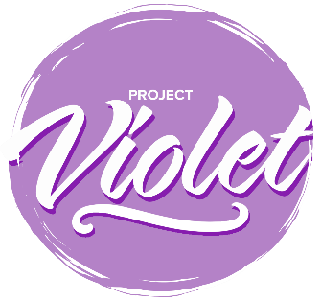

Project Violet – Commitment to Action

Associations

Please send to projectviolet@baptist.org.uk by 30th September 2024.
The commitment to Action responses will be collated and form the basis of a report that will be submitted to the Baptist Union Council in October 2024.

Name of Association | Central Baptist Association
How have you discussed the findings?  For example, meetings and dates | Regional Team meetings x 3  CBA Council of Trustees x 2  Ministers groups in Forums- various  Ministers’ Conference October 2024  NAMS Reflection Day September 2024

These are listed in the priority order agreed at the Project Violet Co-researchers conference on 18 April 2024.

Request Number | Short Name | Accepted | Modified | Declined
R24 | Have a women’s Ministry advisor in each Association | x
R09 | Ensure Ministers’ groups are constructive and inclusive spaces | x
R40 | More opportunities for collaborative and flexible ministry | x
R55 | Improve accompaniment of women Ministers | x
R45 | Ministry to the Deaf Community is Pioneer Ministry | x
R43 | Moderation of the translocal space | x
R34 | Colleges develop a module in inter-cultural ministry and communication |  |  | x
R42 | Intentional support in women’s discernment | x
R04 | Intentional Leadership Development for Women Ministers | x
R06 | Regional ministers proactively discuss terms and conditions during settlement process | x
R17 | Access fund for translocal life and learning | x
R28 | Monitoring data throughout the vocational pathway |  |  | x
R41 | Role models | x
R56 | Use resources that reflect the diversity of Baptist life | x
R14 | Invitation to Regional Justice Hubs to undertake further research using the model developed in Project Violet |  |  | x
R05 | Training in advocacy on behalf of for Ministers and MiTs receiving unequal treatment | x
R23 | Resourcing Regional Justice Hubs | x
R38 | Occupational health service for ministers |  | x
R25 | Promote mutual learning between Urban Expression and Regional Ministers and local churches | x
R35 | Review of the way in which NAMS are inducted into the habit of connection | x

You are invited to offer a narrative, if you would like to, on the decisions you have taken.

